USER GUIDE FOR USING THE APP

1. **Account**
2. ***Register an account***

* Click Register button on Navigation Bar to register as user.

**

* Enter personal information to register form, then click Submit button

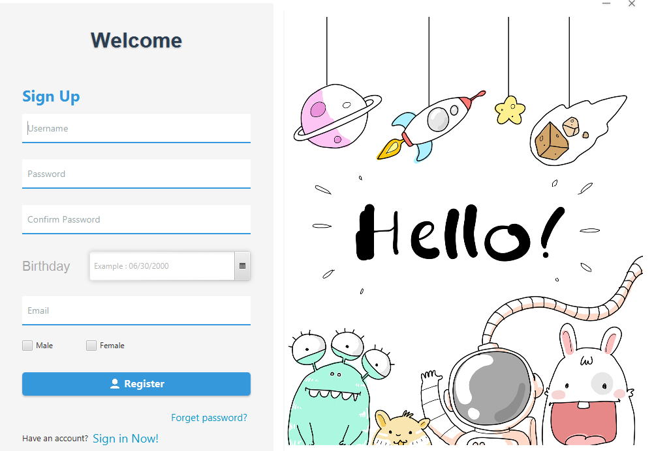

1. ***Login to your account***

* Click Login button on NavBar, then enter username and password match to registered account, then click Login.

***3. View profile,you can view or edit your personal info***

* 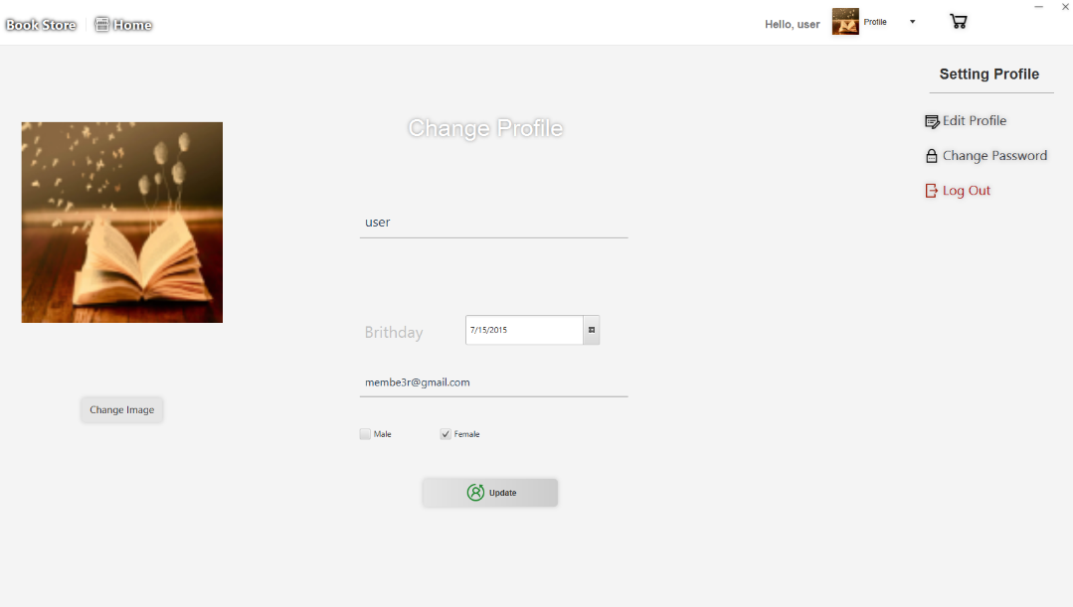*Users can update their information here.*

1. **Products**
2. ***You can buy the book here***

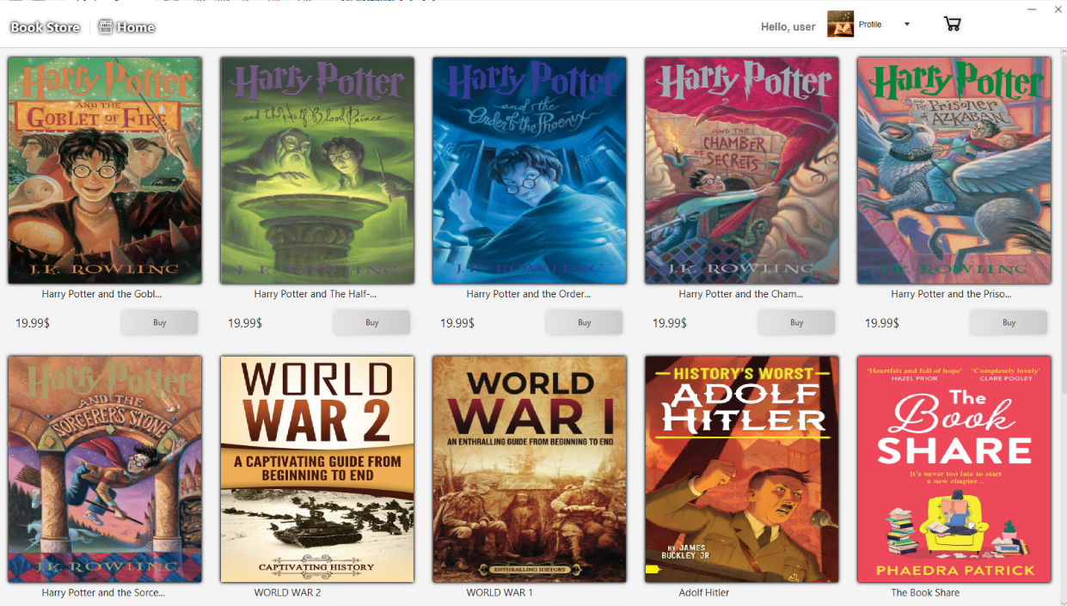

* User can view and buy the books here

1. ***Payment and bill***

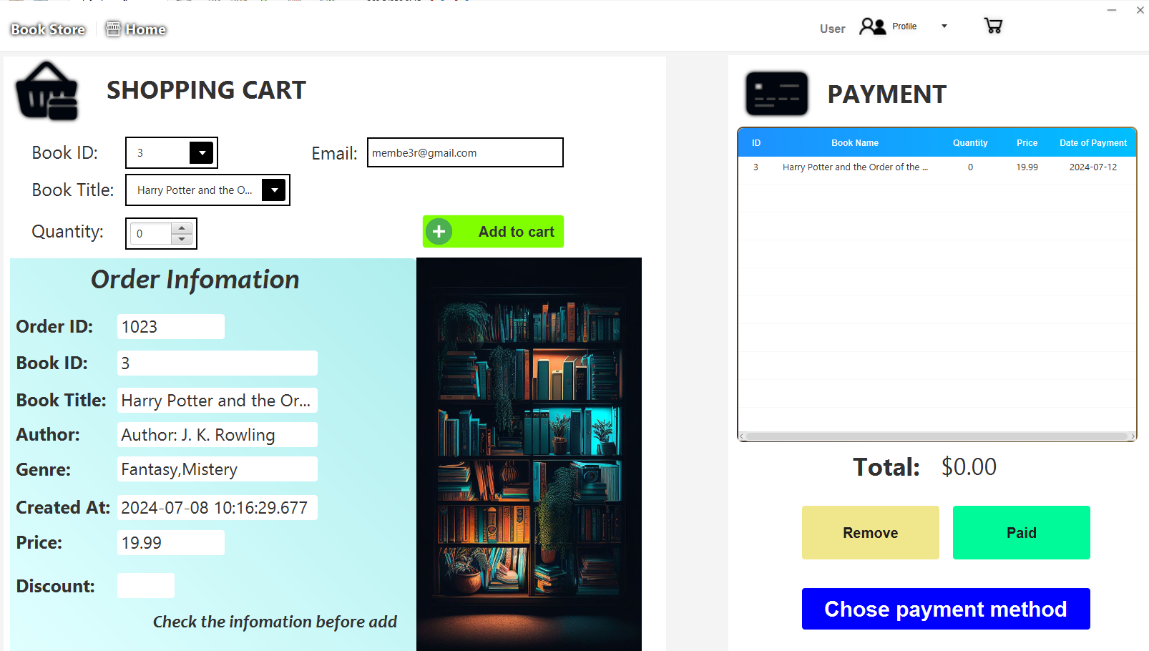

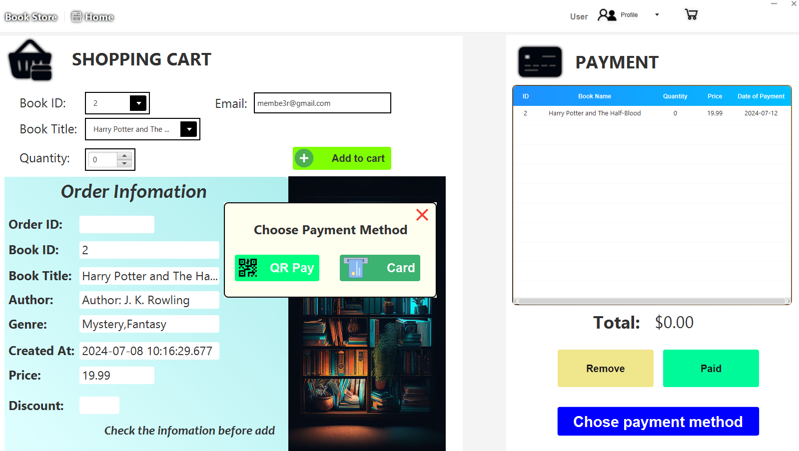

* Users can buy with card or qr code.

* When you have successfully paid.

**ADMIN DASHBOARD**

**ADMIN DASHBOARD:**

**Books**

* **This is the opening page for the bookstore.**

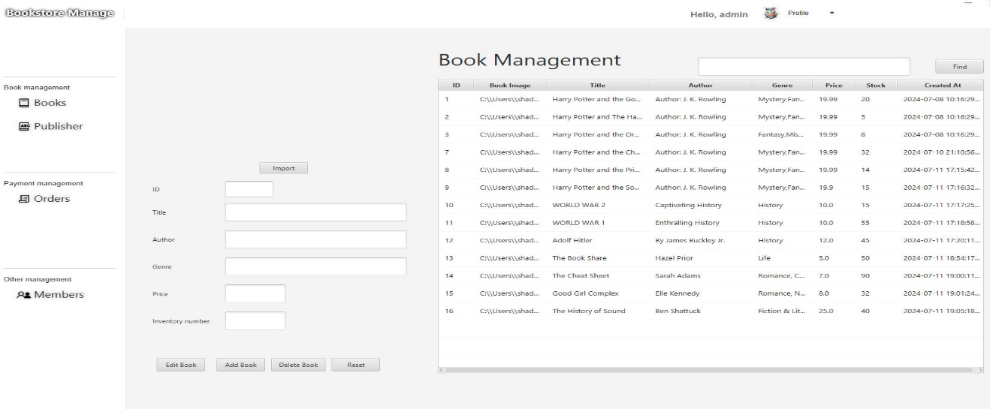

* Admin can add edit delete and search for books here

**Publisher**

* Click publisher to go to publisher page
* 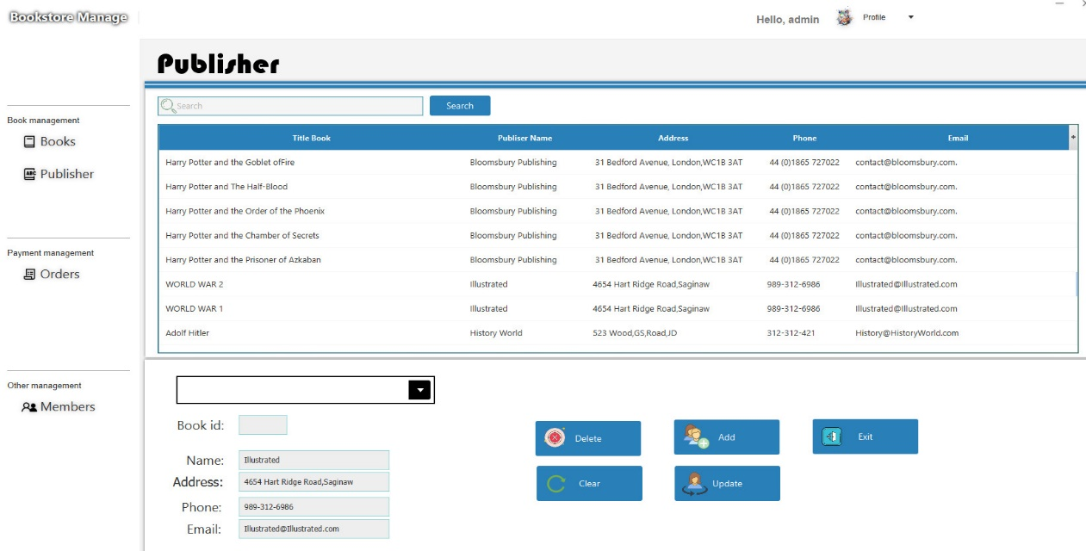
* Admin can edit book seller information here

**Order**

* This page stores each customer's transaction information.

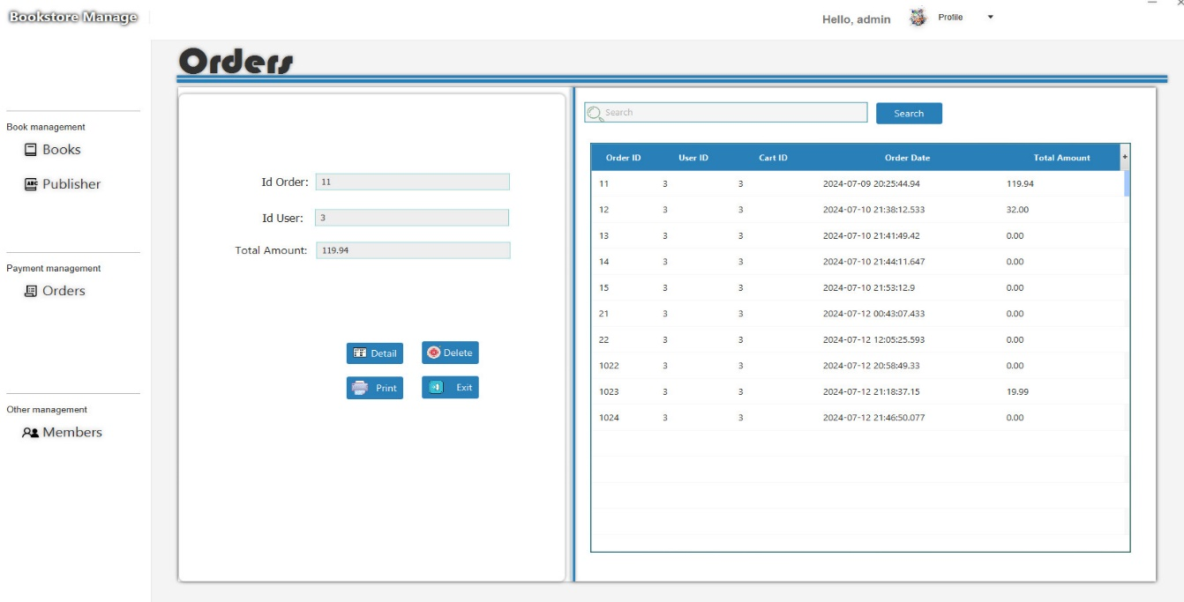

* The administrator can view customer details and can print them out, as well as edit or delete customer information.

**Menbers**

* This page displays user information.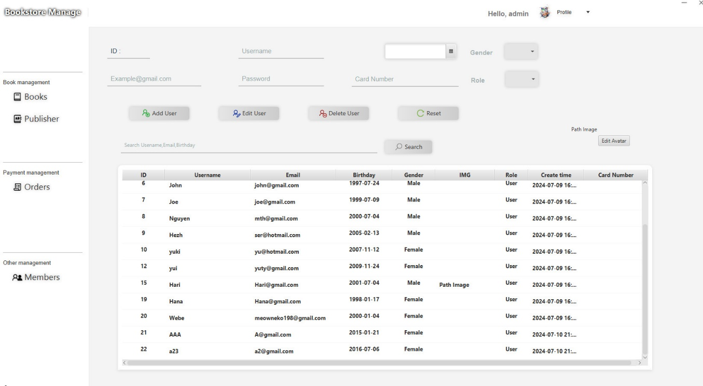
* Administrator can add edit or delete users